# How to Setup CentOS 7 on AWS

This tutorial will show you how to create a CentOS 7 instance on AWS. We assume that you already have you AWS account created and that you are logged in already.

**Step 1**

Click Services and then EC2

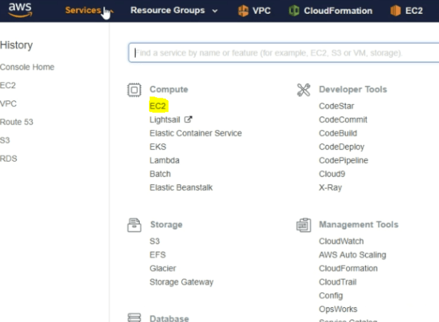

**Step 2**

Click Launch Instance

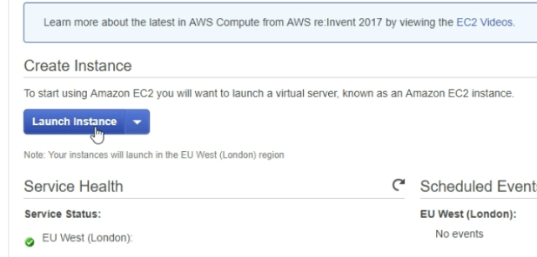

**Step 3**

* Click AWS Marketplace
* Search for CentOS
* Select the top result – CentOS7

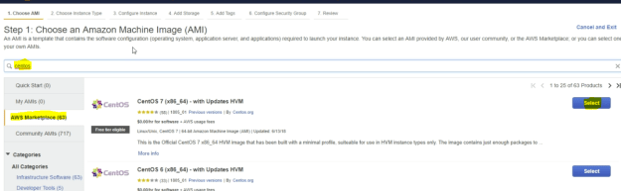

**Step 4**

Click Continue

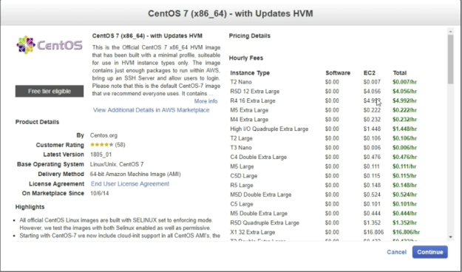

**Step 5**

Select your machine type and click Next Configure Instance details. In our case we will select the t2.micro instance as it is free tier eligible.

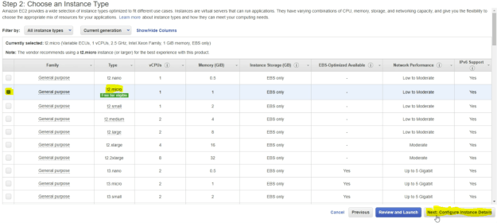

**Step 6**

Change Auto-assign public IP to Enable and click Next: Add storage.

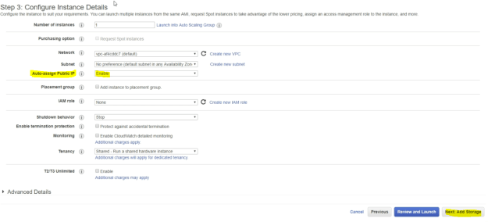

**Step 7**

Leave the defaults and click Next:Add Tags

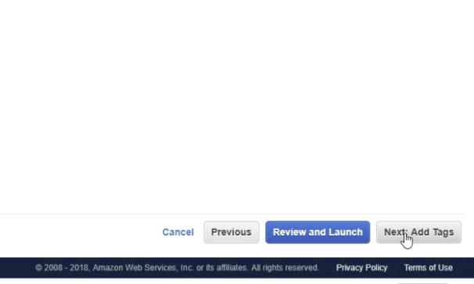

**Step 8**

Click Next: Configure Security Group

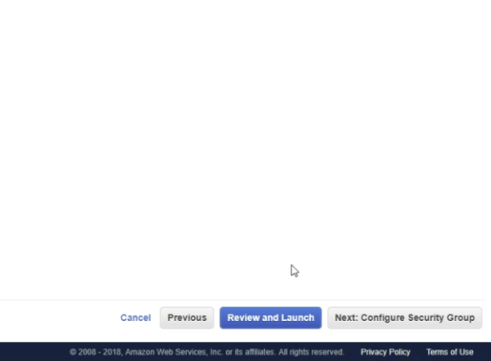

**Step 9**

Click review and Launch.

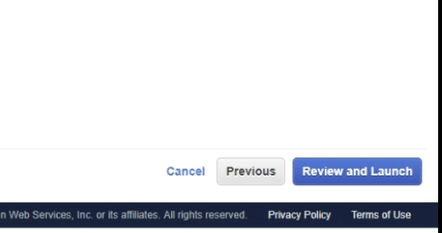

**Step 10**

Review your settings and then click Launch.

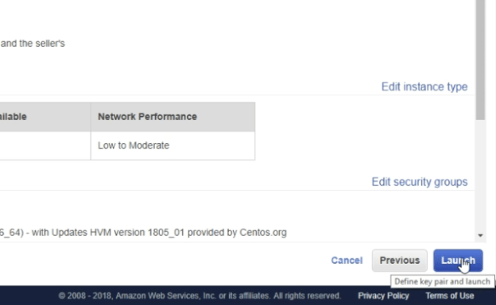

**Step 11**

In the drop down menu select create a new key pair, give the key pair a name and Download the Key Pair, then click launch Instances.

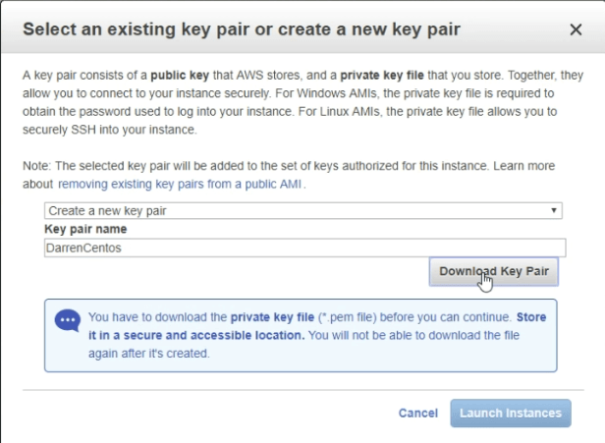

**Step 12**

Click your instance ID to see the instance. 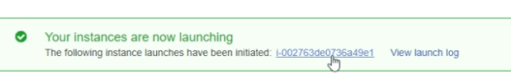

You should now see your instance.

https://i1.wp.com/darrenoneill.eu/wp-content/uploads/2018/10/img_5bcb1bd6c01b6.png?w=625

**Step 13**

To connect to our instance we will need to convert the key we downloaded, to do so we will use putty and puttygen they can be downloaded form here: https://www.putty.org/

Open puttygen and click Load

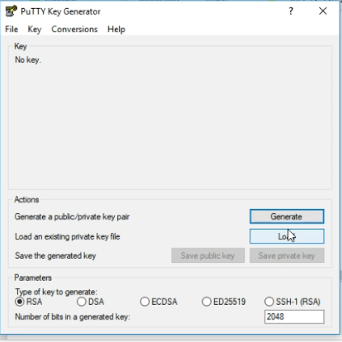

**Step 14**

Navigate to where you downloaded your key, click all files, click on your key and click open.

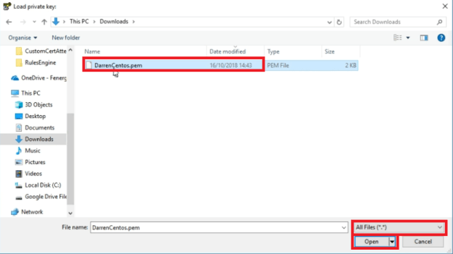

**Step 15**

Now click Save Private key, when prompted click yes you want to save without a passphrase.

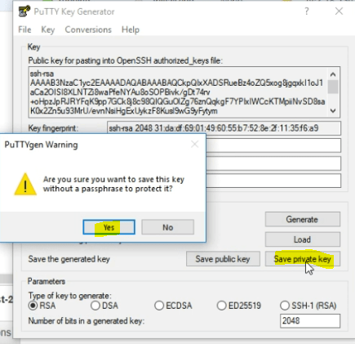

**Step 16**

Now open putty and enter your public IP into the host name or IP address field, then expand SSH on the left had side.

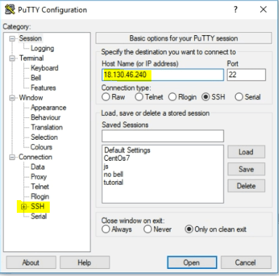

**Step 17**

Click auth and then browse, navigate to where you saved your key and select it.

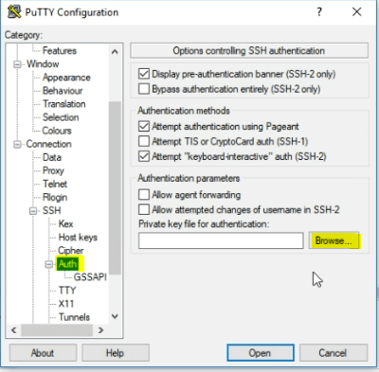

**Step 18**

Now click open

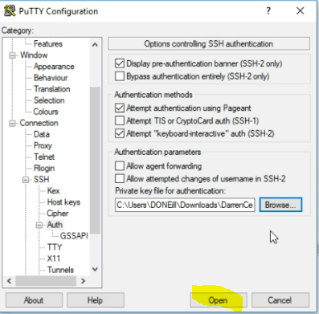

**Step 19**

Click Yes

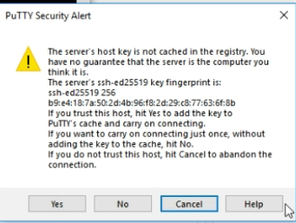

**Step 20**

Enter centos as the username and click enter.

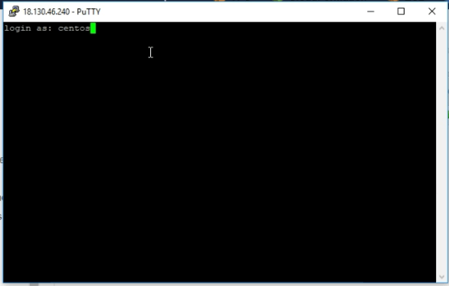

You will now be logged in

